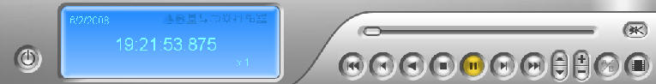
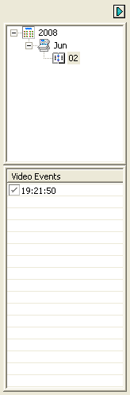
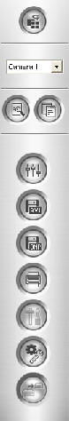
Player Operating Directions
These directions will help walk you through operating the Remote Video Player.
Rather playing from this CD/DVD disk OR using the Elevated Shots Web-Server to access your archived videos, these instructions will help explain the player buttons. The buttons at the bottom of the player are pretty self explanatory of what they do. Play / Pause / Stop etc... The side bar has a few 'Save' type buttons which will give you different ways of saving pictures or videos in different 'Windows - user friendly' formats.
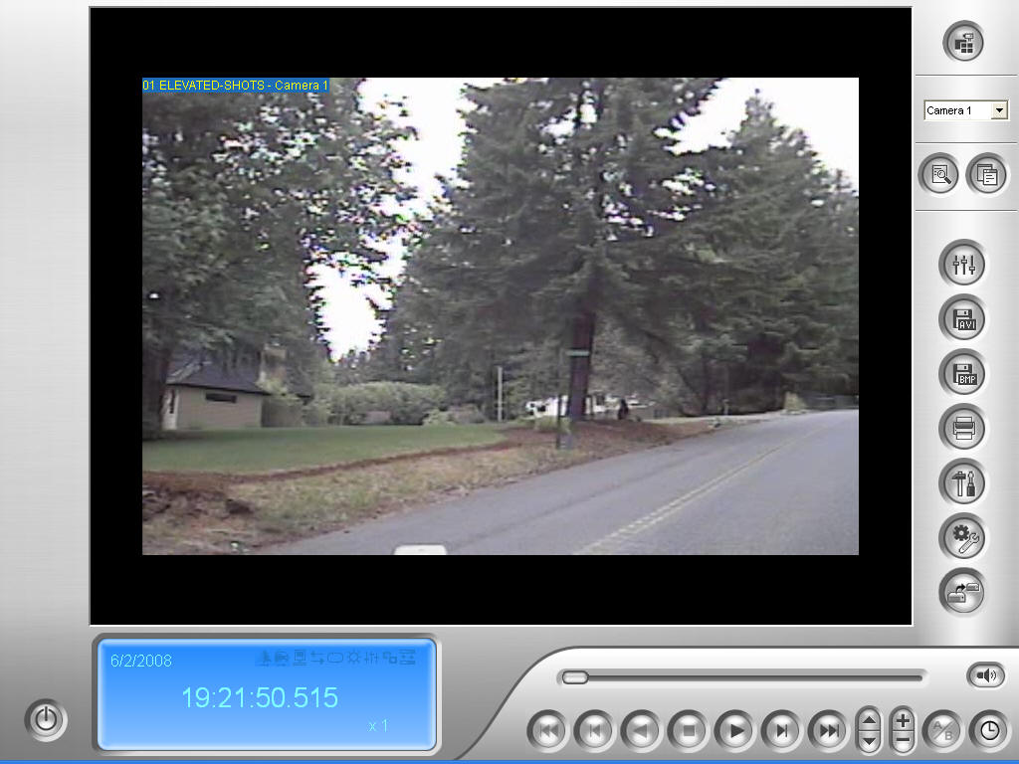 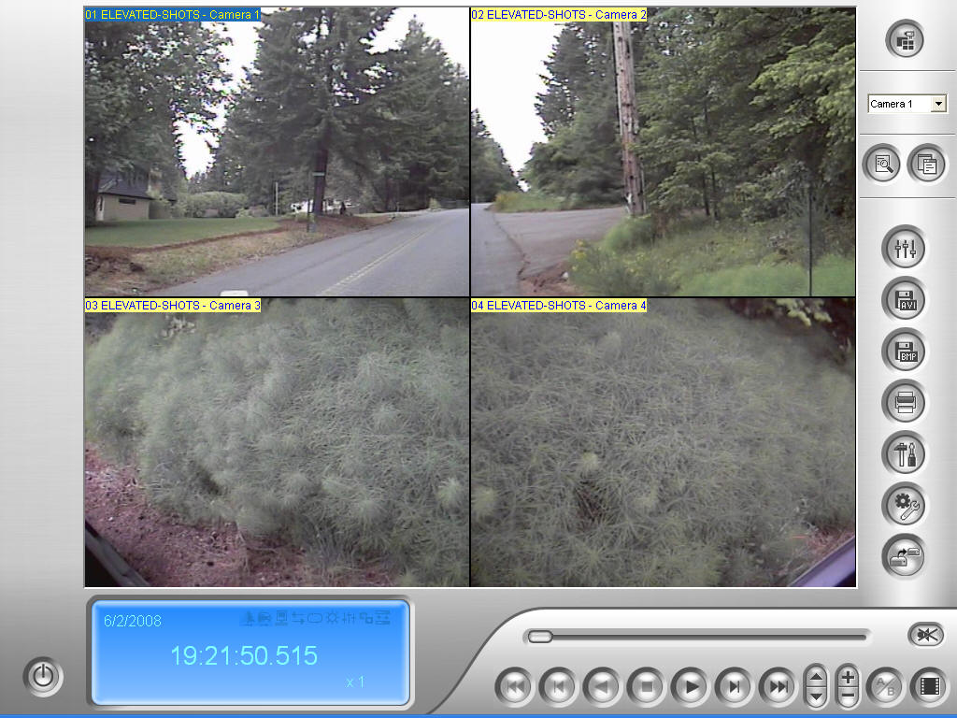 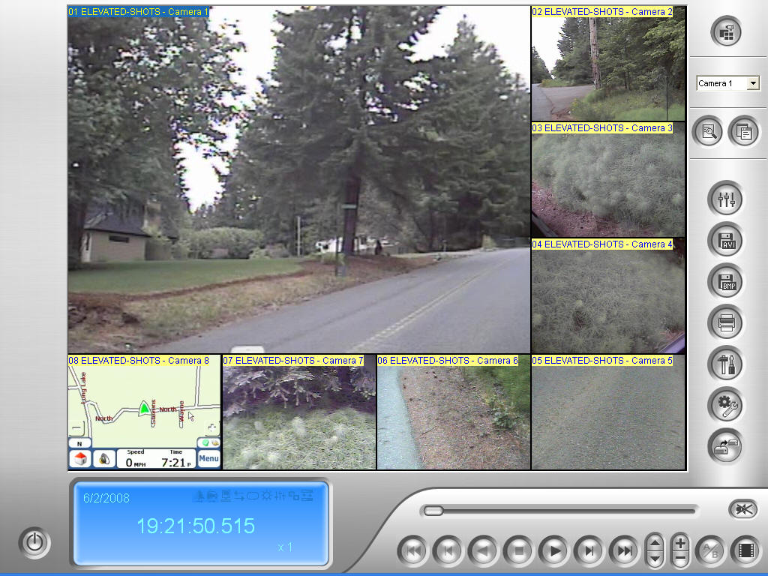
View
Once login is complete the Remote Player opens with the Single-View as the default:
This can easily be changed to Quad-View or Multi-View by clicking on the upper right corner button and choosing from the drop down available.
Multi-View can change its configuration depending on the quantity of cameras at the time the recording took place.
Each separate camera can be moved to the 'big' spot by clicking once on the small screen. The large screen will change places with the small one automatically.
Lower Buttons
The buttons at the bottom of the player consist of: Play / Pause / Stop - Fast Forward & Rewind - Next & Previous Frame - End & Home. There's also the ability to speed it up to x32 or slow it down to x1/8 speed. Zoom in and then zoom back out is also available. The far lower right button enables the change from Frame to Frame or Real Time depending on the flow you want to watch.
Side Buttons
Single / Quad / Multi-View
Left button - Advanced Search Button
Right button - Open & hide the Search Side Bar
Advanced camera adjustments:
Contrast / Brightness / Sharpness
Save an .AVI (Video) file:
Saves a short video file that can be played back on Windows Media Player
Save a .BMP (Picture) file:
Saves a single picture file of whatever screen shot is selected at time of pause
Print a screen shot of all cameras in view directly to your printer
Ability to type a short message that will print on the page Search Side Bar
The last three tool buttons are used for advanced setup options (Date & Time of Run)
Button Characteristics
The Play button turns into the Pause button - While playing, click the Stop button and it will take you back to the very beginning of that session (home).
Save and Print buttons are enabled once the Pause or Stop button is pushed - This is required in order to access their functions and capabilities.
Speed Up and Slow Down buttons will stay at the rate they're put until such time the opposite button is pushed for further adjustment the other direction. Default is x1 when the player starts.
Zoom In and Zoom Out act the same as the speed buttons where they will stay, where they are left, until adjusted back. Zoom Out wont work until Zoom In has been active.

